9:00 – 10:00 – Adding Player Animations
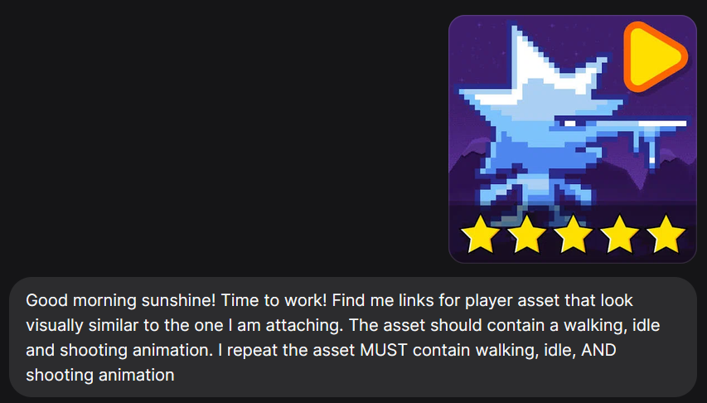

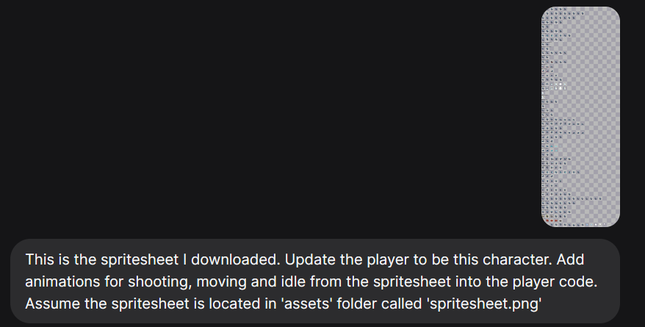
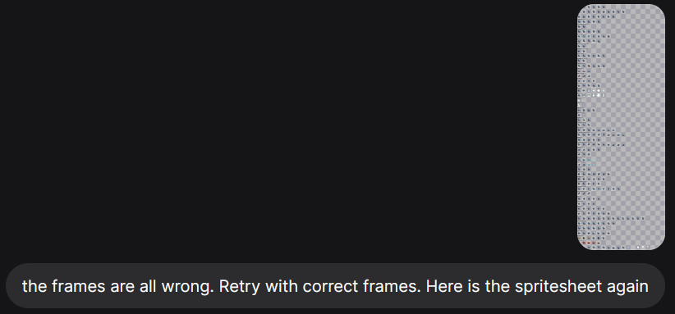
The AI could NOT extract exact squares from the image. So, I tried giving it individual animation spritesheets rather than the whole atlas.
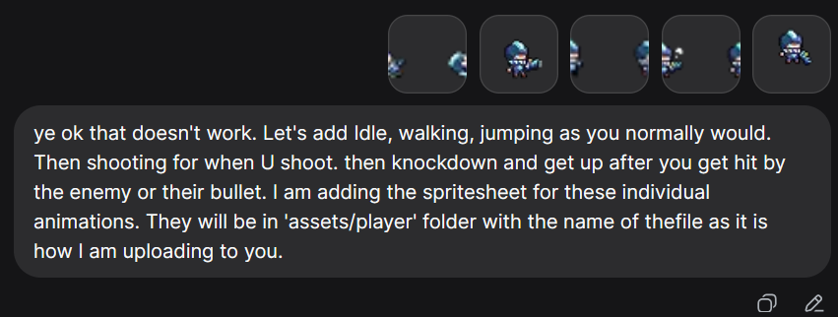
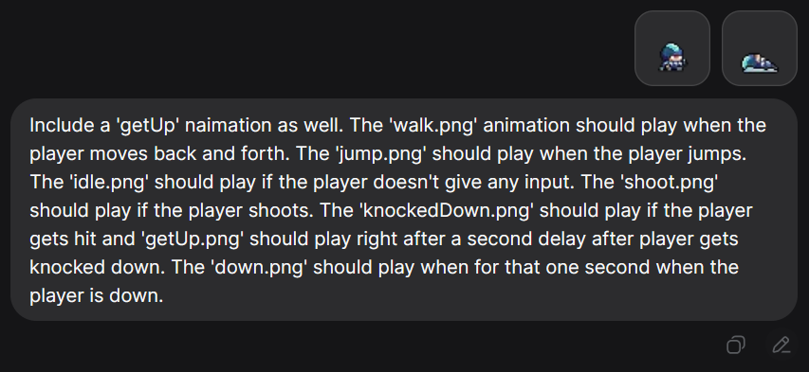

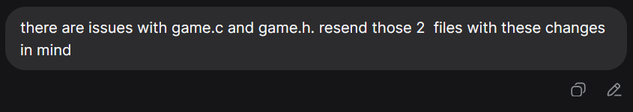
Issues faced includes:
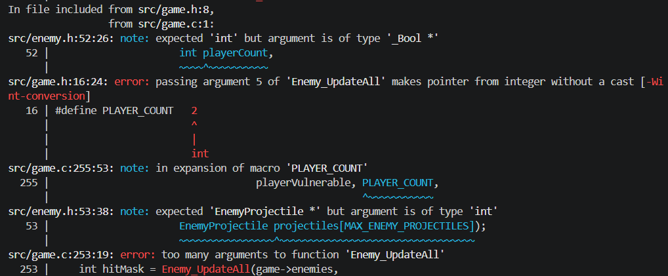
The AI updated some of the files but forgot to update ALL files the change affected such as enemy.c. Had to make it fix it.
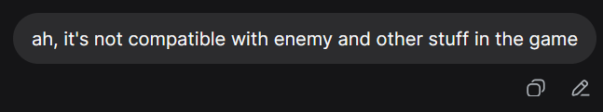

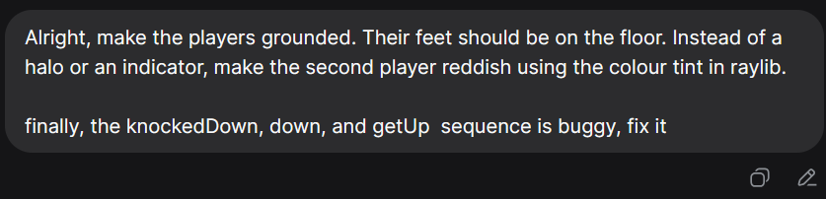
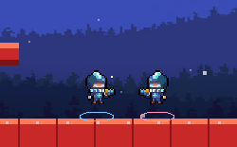
Floating players with ring indicators (that I did NOT want)

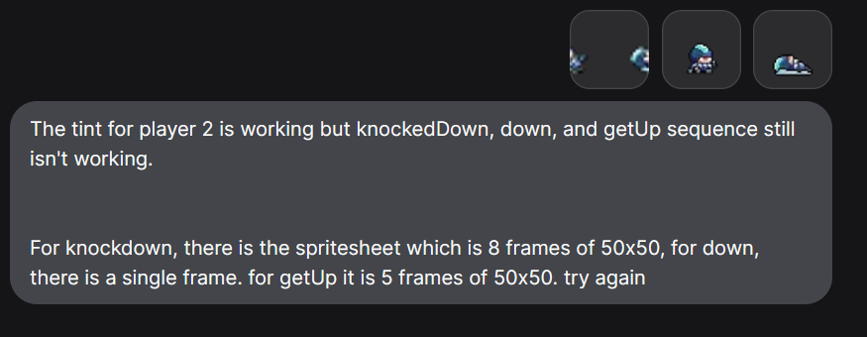
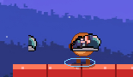
Example of broken animation ^
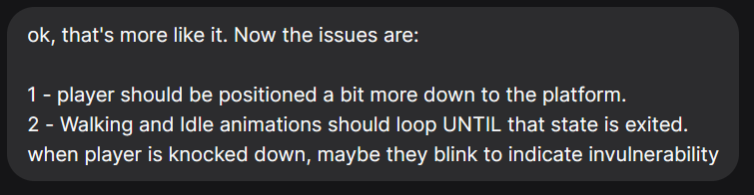

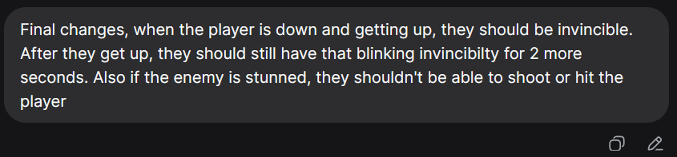

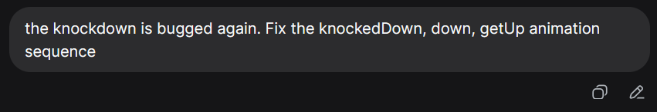
The issue highlighted in previous page with image was fixed but same feature broke after last two changes. It had issues with state transitions from knocked Down -> staying Down - > getting up.

^ Sheesh – All that thinking to still produce broken code:
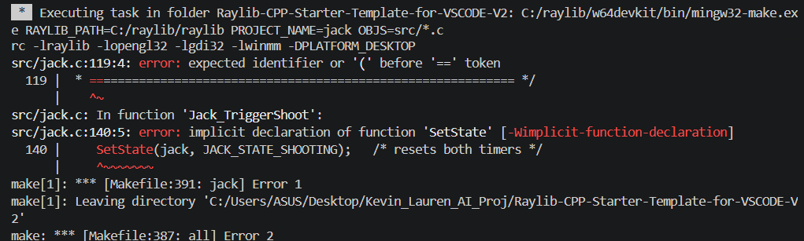
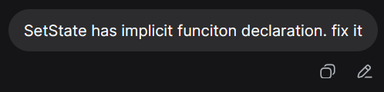
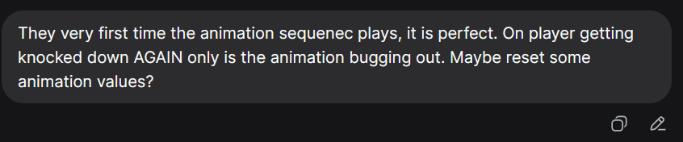
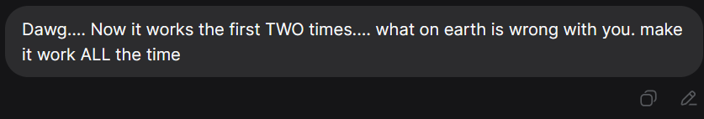
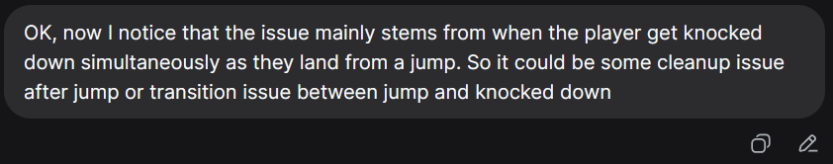
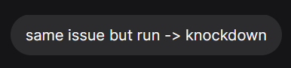

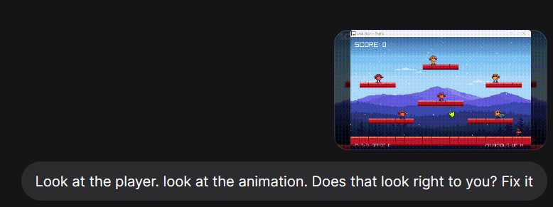
GIF attached is similar to one below:
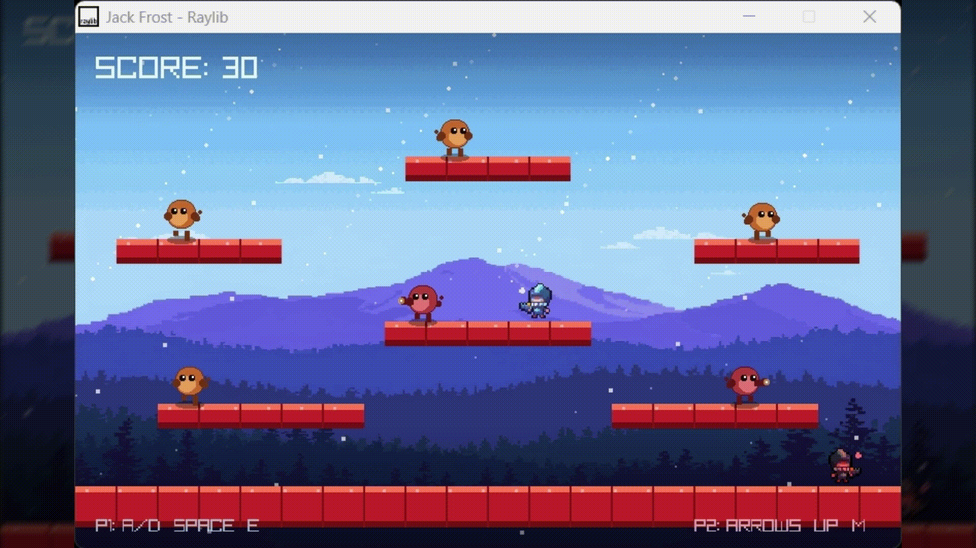

The AI being AI, completely ignored everything I been talking about till now and instead simply increased the size of the players by a lot. And didn’t fix anything that was broken. So let’s just say I wasn’t the most thrilled

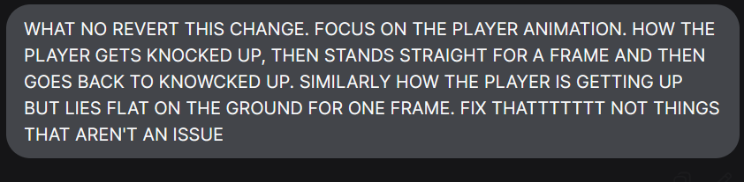
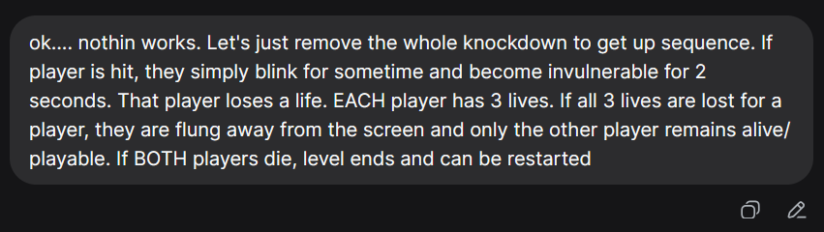
^ Works immediately!

